**Practical no.-**18

**Title:** Develop a program to implement new activity using explicit intent and implicit intent.

**Roll No.:**15 **Batch-** A **Date of Performance:** 29/02/2024

**activity_main.xml**

<?xml version="1.0" encoding="utf-8"?>

<AbsoluteLayout xmlns:android="http://schemas.android.com/apk/res/android"

xmlns:app="http://schemas.android.com/apk/res-auto"

xmlns:tools="http://schemas.android.com/tools"

android:layout_width="match_parent"

android:layout_height="match_parent"

tools:context=".MainActivity">

<EditText

android:id="@+id/et1"

android:layout_width="320dp"

android:layout_height="wrap_content"

android:layout_x="20dp"

android:layout_y="248dp"

android:hint="Enter URL"

android:inputType="textUri" />

<Button

android:id="@+id/b1"

android:layout_width="wrap_content"

android:layout_height="wrap_content"

android:layout_x="125dp"

android:layout_y="377dp"

android:text="Navigate" />

</AbsoluteLayout>

**MainActivity.java**

package com.example.pract_181intent;

import androidx.appcompat.app.AppCompatActivity;

import android.annotation.SuppressLint;

import android.content.*;

import android.net.Uri;

import android.os.Bundle;

import android.view.View;

import android.widget.*;

public class MainActivity extends AppCompatActivity {

Button b1;

EditText et1;

@SuppressLint("MissingInflatedId")

@Override

protected void onCreate(Bundle savedInstanceState) {

super.onCreate(savedInstanceState);

setContentView(R.layout.activity_main);

b1=(Button) findViewById(R.id.b1);

et1=(EditText) findViewById(R.id.et1);

b1.setOnClickListener(new View.OnClickListener() {

public void onClick(View v) {

String url= String.valueOf(et1.getText());

if(url.contains("https://www.google.com"))

{

Intent intent=new Intent(Intent.ACTION_VIEW,Uri.parse(url));

startActivity(intent);

}

else {

Toast.makeText(MainActivity.this,"Enter Valid Google URL",Toast.LENGTH_SHORT).show();

}

}

});

}

}

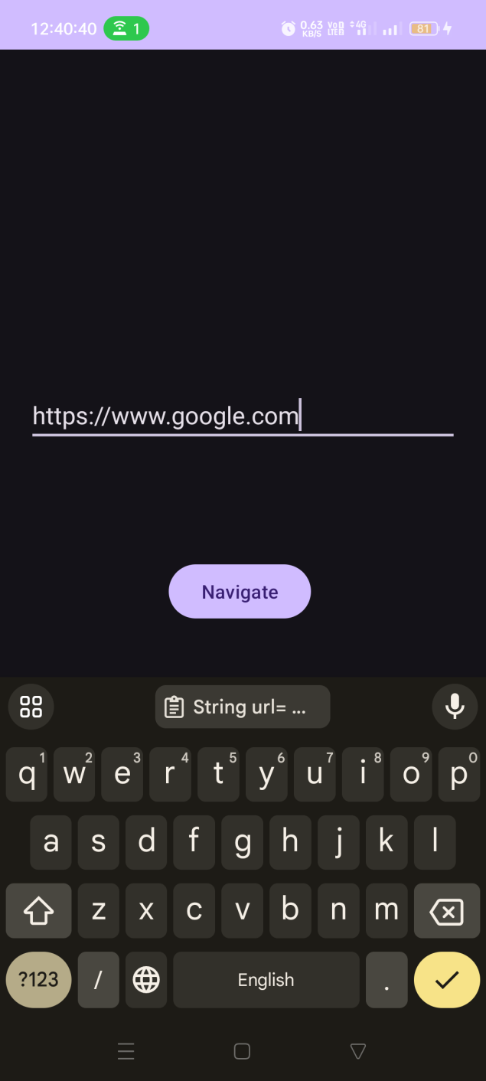

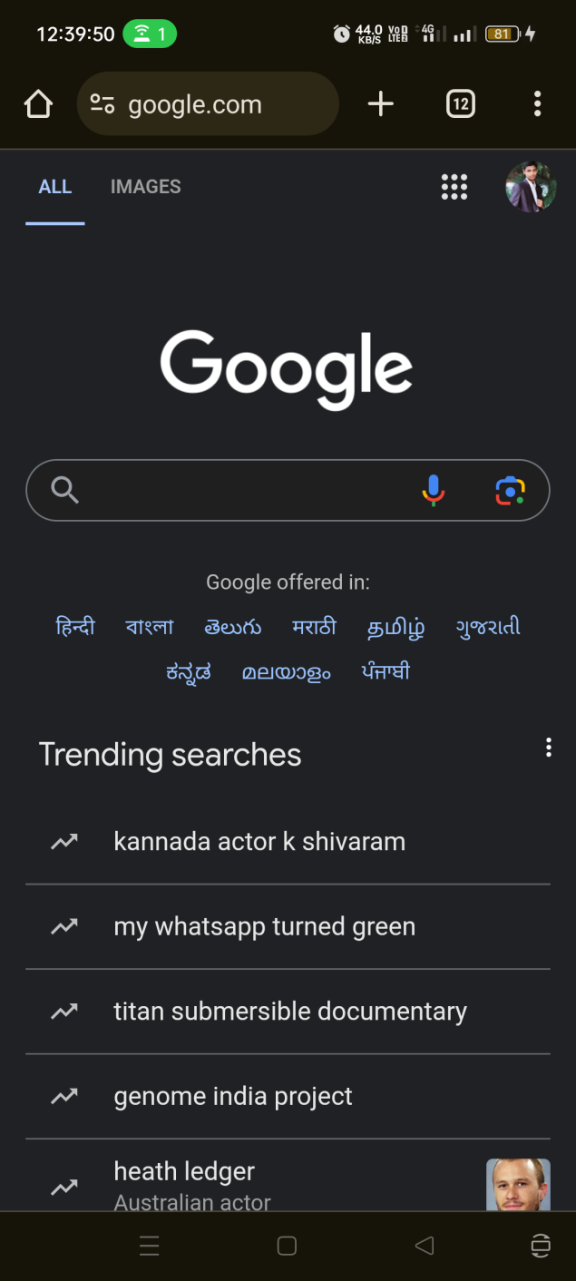

**activity_main.xml**

<?xml version="1.0" encoding="utf-8"?>

<LinearLayout xmlns:android="http://schemas.android.com/apk/res/android"

xmlns:app="http://schemas.android.com/apk/res-auto"

xmlns:tools="http://schemas.android.com/tools"

android:layout_width="match_parent"

android:layout_height="match_parent"

android:gravity="center"

tools:context=".MainActivity">

<Button

android:id="@+id/b1"

android:layout_width="wrap_content"

android:layout_height="wrap_content"

android:text="Start Dialer" />

</LinearLayout>

**MainActivity.java**

package com.example.pract_182intent;

import androidx.appcompat.app.AppCompatActivity;

import android.annotation.SuppressLint;

import android.content.Intent;

import android.os.Bundle;

import android.view.View;

import android.widget.*;

public class MainActivity extends AppCompatActivity {

Button b1;

@SuppressLint("MissingInflatedId")

@Override

protected void onCreate(Bundle savedInstanceState) {

super.onCreate(savedInstanceState);

setContentView(R.layout.activity_main);

b1=( Button) findViewById(R.id.b1);

b1.setOnClickListener(new View.OnClickListener() {

@Override

public void onClick(View v) {

Intent intent=new Intent(Intent.ACTION_DIAL);

startActivity(intent);

}

});

}

}

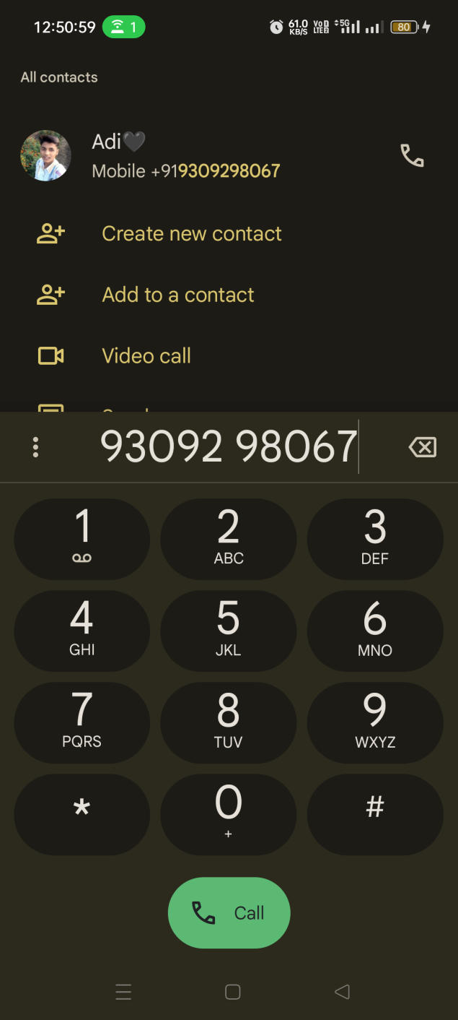

**activity_main.xml**

<?xml version="1.0" encoding="utf-8"?>

<LinearLayout xmlns:android="http://schemas.android.com/apk/res/android"

android:layout_width="match_parent"

android:layout_height="match_parent"

android:orientation="vertical"

android:padding="16dp"

android:gravity="center">

<EditText

android:id="@+id/etxt"

android:layout_width="237dp"

android:layout_height="wrap_content"

android:hint="Enter a number"

android:inputType="number" />

<Button

android:id="@+id/btn"

android:layout_width="wrap_content"

android:layout_height="wrap_content"

android:layout_marginTop="40dp"

android:text="Factorial" />

</LinearLayout>

**activity_second.xml**

<?xml version="1.0" encoding="utf-8"?>

<LinearLayout xmlns:android="http://schemas.android.com/apk/res/android"

android:layout_width="match_parent"

android:layout_height="match_parent"

android:orientation="vertical"

android:gravity="center">

<TextView

android:id="@+id/ftxt"

android:layout_width="match_parent"

android:layout_height="wrap_content"

android:textAlignment="center"

android:textSize="20sp"

android:textStyle="bold"/>

</LinearLayout>

**MainActivity.java**

package com.example.pract_183intent;

import androidx.appcompat.app.AppCompatActivity;

import android.annotation.SuppressLint;

import android.content.Intent;

import android.os.Bundle;

import android.view.View;

import android.widget.*;

public class MainActivity extends AppCompatActivity {

Button btn;

EditText etxt;

@SuppressLint("MissingInflatedId")

@Override

protected void onCreate(Bundle savedInstanceState) {

super.onCreate(savedInstanceState);

setContentView(R.layout.activity_main);

btn=(Button) findViewById(R.id.btn);

etxt=(EditText) findViewById(R.id.etxt);

btn.setOnClickListener(new View.OnClickListener() {

@Override

public void onClick(View v) {

int number=Integer.parseInt(String.valueOf(etxt.getText()));

Intent intent=new Intent(MainActivity.this,SecondActivity.class);

intent.putExtra("number",number);

startActivity(intent);

}

});

}

}

**SecondActivity.java**

package com.example.pract_183intent;

import androidx.appcompat.app.AppCompatActivity;

import android.os.Bundle;

import android.widget.*;

public class SecondActivity extends AppCompatActivity {

TextView ftxt;

int fact=1;

@Override

protected void onCreate(Bundle savedInstanceState) {

super.onCreate(savedInstanceState);

setContentView(R.layout.activity_second);

int number=getIntent().getIntExtra("number",0);

ftxt=(TextView) findViewById(R.id.ftxt);

int factorial = calfactorial(number);

ftxt.setText("Factorial of " + number + " = " + factorial);

}

protected int calfactorial(int number)

{

for(int i=1;i<=number;i++)

{

fact=fact*i;

}

return fact;

}

}

